**MAMA BRONZE ONLINE**

**HARDWARE BLOCK DIAGRAM:**

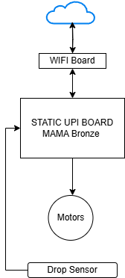

**AWS BLOCK DIAGRAM:**

mcn_cnf.txt

{

“mid” : “MACH01”,

“ssid” : ”xxxxx”,

“pwd” : “12345678”

}

**NETWORK CONNECTION:**

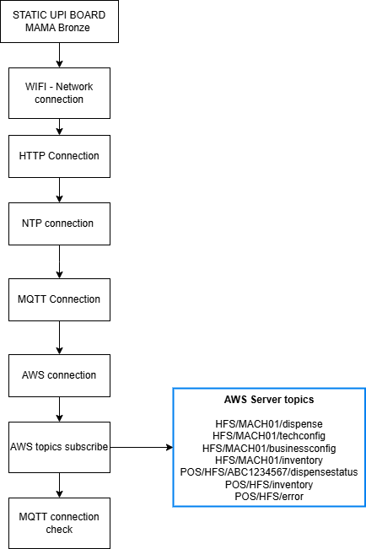

tech

{ "mid":"BRNZ01", "key":"ABAB", "crc":200, "nss":4, "bff":0, "bfc":2, "nse":4, "cdf":1, "bdf":1, "mff":1, "mcf":1, "mtp":1, "mlc":10, "mhc":30, "dsf":0, "dsc":0, "gps":1, "gsm":1, "wfi":1, "tsf":1, "dfc":2, "asl":2, "spg":[ { "spn":1, "psf":1, "ssc":30, "mrp":1, "mtp":1, "mon":2500, "nmc":[ 1 ] }, { "spn":2, "psf":1, "ssc":30, "mrp":1, "mtp":1, "mon":2840, "nmc":[ 2 ] }, { "spn":3, "psf":1, "ssc":30, "mrp":1, "mtp":1, "mon":2860, "nmc":[ 3 ] }, { "spn":4, "psf":1, "ssc":30, "mrp":1, "mtp":1, "mon":2890, "nmc":[ 4 ] } ], "rea":[ { "spn":1, "sec":177, "dec":81, "mec":83 }, { "spn":2, "sec":177, "dec":81, "mec":83 }, { "spn":3, "sec":177, "dec":81, "mec":83 }, { "spn":4, "sec":177, "dec":81, "mec":83 } ] }

IF USER WIFI NEED TO SET

{ "rcf":{ "wsn":"kvmc", "wpd":"vmc@12345" }, "mid":"MACH01", "key":"ABAB", "crc":200, "nss":4, "bff":0, "bfc":2, "nse":4, "cdf":1, "bdf":1, "mff":0, "mcf":0, "mtp":1, "mlc":10, "mhc":30, "dsf":0, "dsc":0, "gps":1, "gsm":1, "wfi":1, "tsf":1, "dfc":2, "asl":2, "spg":[ { "spn":1, "psf":1, "ssc":30, "mrp":1, "mtp":1, "mon":4000, "nmc":[ 1 ] }, { "spn":2, "psf":1, "ssc":30, "mrp":1, "mtp":1, "mon":4000, "nmc":[ 2 ] }, { "spn":3, "psf":1, "ssc":30, "mrp":1, "mtp":1, "mon":4000, "nmc":[ 3 ] }, { "spn":4, "psf":1, "ssc":30, "mrp":1, "mtp":1, "mon":4000, "nmc":[ 4 ] } ], "rea":[ { "spn":1, "sec":177, "dec":81, "mec":83 }, { "spn":2, "sec":177, "dec":81, "mec":83 }, { "spn":3, "sec":177, "dec":81, "mec":83 }, { "spn":4, "sec":177, "dec":81, "mec":83 } ] }

business

{ "mid":"MACH01", "key":"ABAB", "crc":200, "men":1, "imx":2, "qmx":3, "ica":[ { "spn":1, "iid":1, "itp":2, "asn":[ 1, 2, 3, 4 ] }, { "spn":2, "iid":1, "itp":2, "asn":[ 2, 3, 4, 1 ] }, { "spn":3, "iid":1, "itp":2, "asn":[ 3, 4, 1, 2 ] }, { "spn":4, "iid":1, "itp":2, "asn":[ 4, 1, 2, 3 ] } ] }

inventory

{ "mid":"MACH01", "key":"ABAB", "crc":200, "iua":[ { "iid":23, "sid":19, "spn":1, "clq":5, "tqt":30 }, { "iid":23, "sid":19, "spn":2, "clq":5, "tqt":30 }, { "iid":23, "sid":19, "spn":3, "clq":5, "tqt":30 }, { "iid":23, "sid":19, "spn":4, "clq":5, "tqt":30 } ] }

dispen

{ "mid":"MACH01", "oid":"ORD_MACH01_101", "key":"ABAB", "crc":200, "ida":[ { "spn":1, "iid":1, "qty":1 } ] }

HFS/MACH01/dispense HFS/MACH01/techconfig HFS/MACH01/businessconfig HFS/MACH01/inventory POS/HFS/ABC1234567/dispensestatus POS/HFS/inventory POS/HFS/error